BAZIL UDDIN KHAN
24K-0559
BSCS-1H
TASK1).
1). 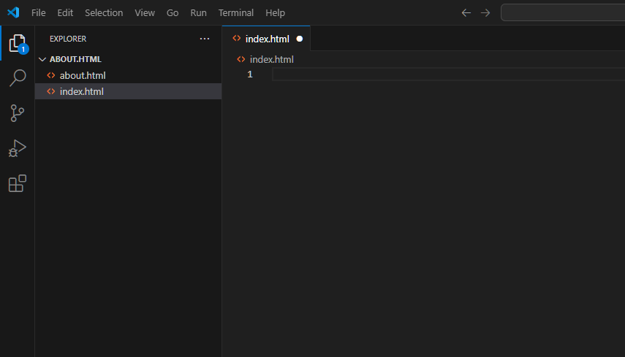
2). 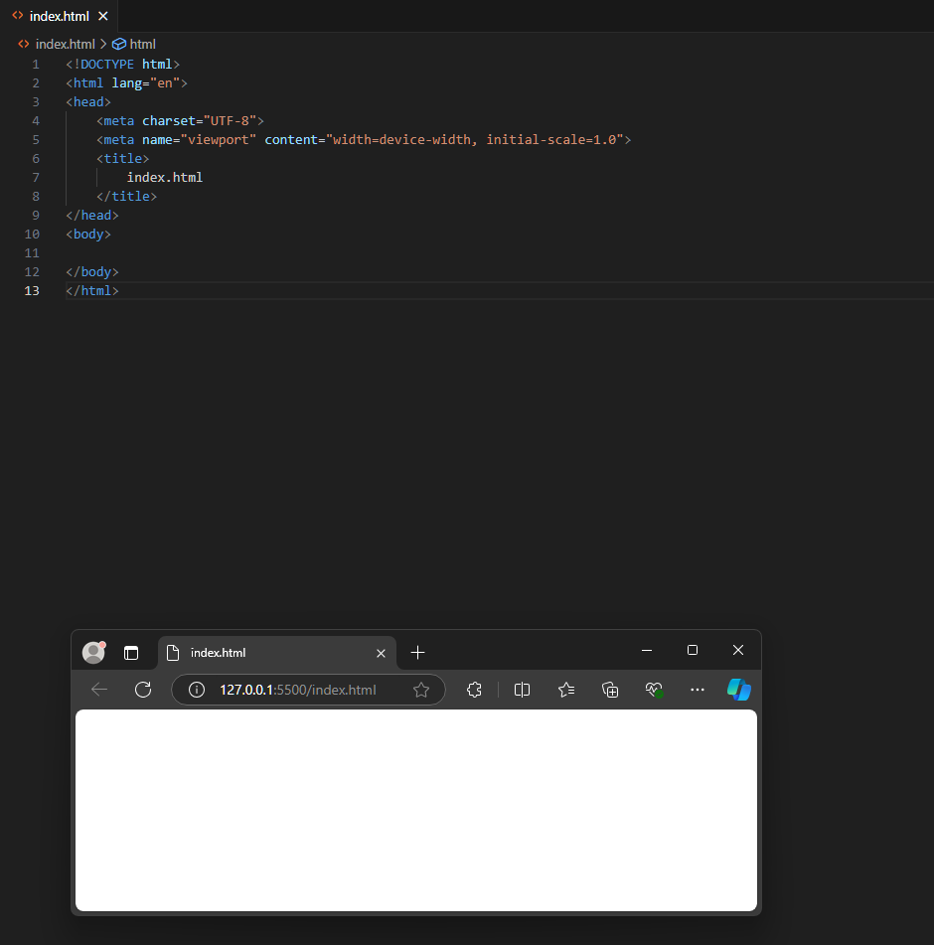
Code:
<!DOCTYPE html>
<html lang="en">
<head>
<meta charset="UTF-8">
<meta name="viewport" content="width=device-width, initial-scale=1.0">
<title>
index.html
</title>
</head>
<body>

</body>
</html>

Task2).
1). 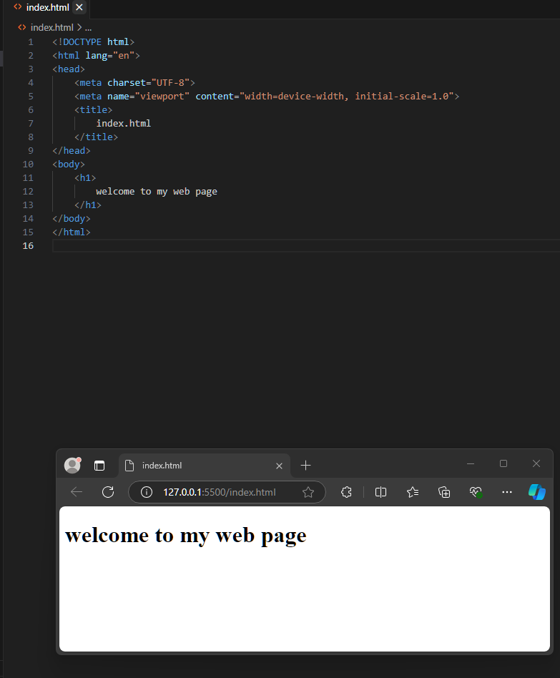
Code:
<!DOCTYPE html>
<html lang="en">
<head>
<meta charset="UTF-8">
<meta name="viewport" content="width=device-width, initial-scale=1.0">
<title>
index.html
</title>
</head>
<body>
<h1>
welcome to my web page
</h1>
</body>
</html>

2). 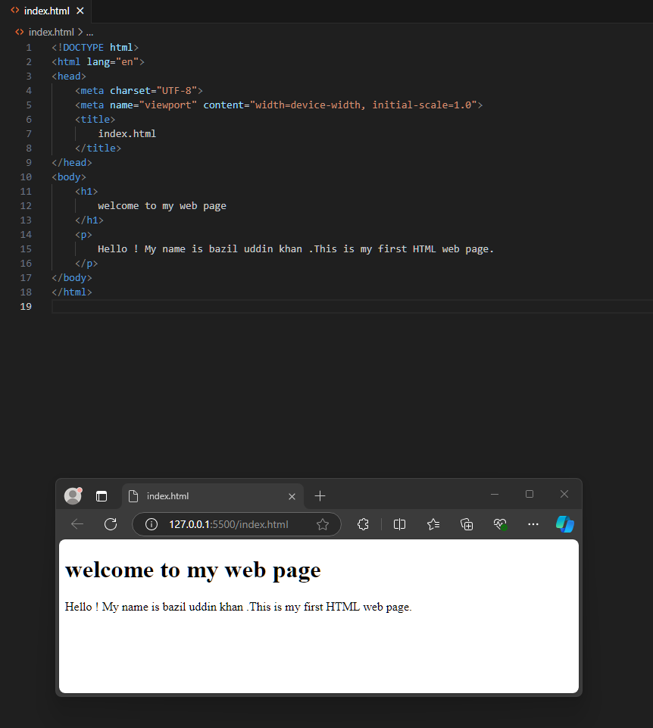
Code:
<!DOCTYPE html>
<html lang="en">
<head>
<meta charset="UTF-8">
<meta name="viewport" content="width=device-width, initial-scale=1.0">
<title>
index.html
</title>
</head>
<body>
<h1>
welcome to my web page
</h1>
<p>
Hello ! My name is bazil uddin khan .This is my first HTML web page.
</p>
</body>
</html>

3). 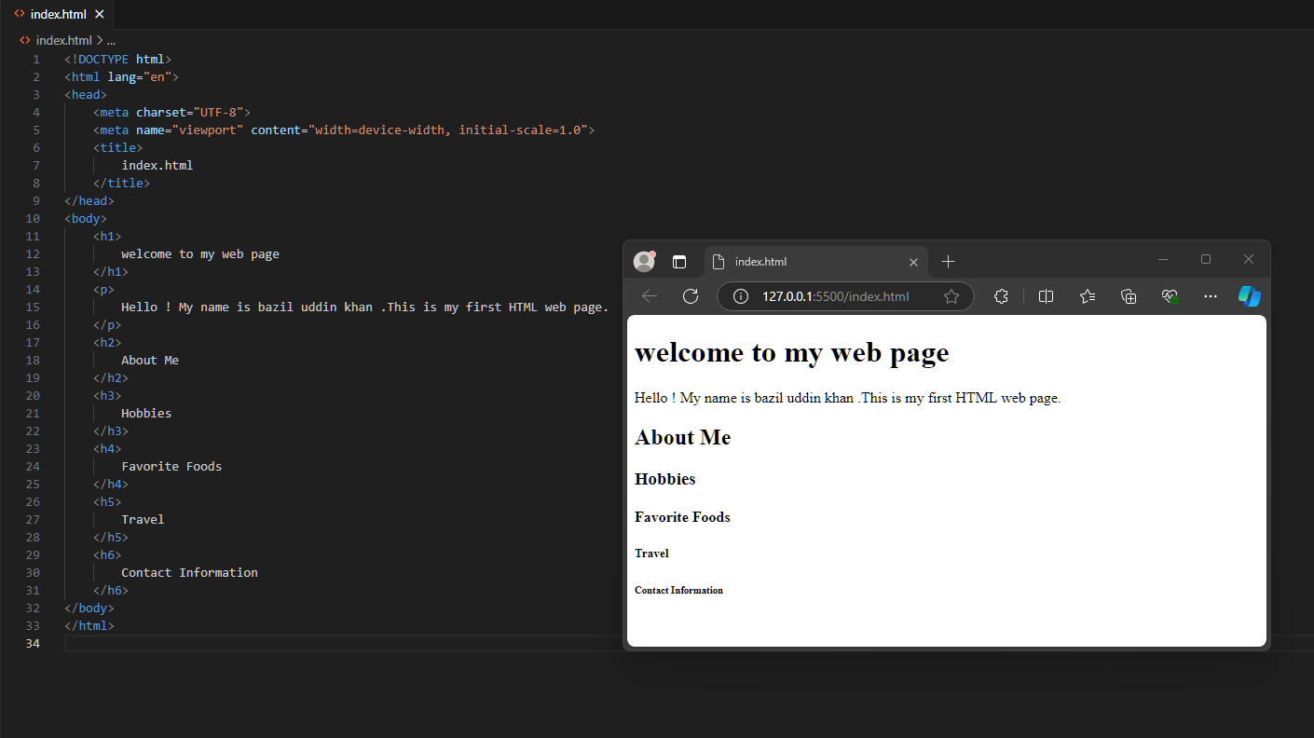
CODE:
<!DOCTYPE html>
<html lang="en">
<head>
<meta charset="UTF-8">
<meta name="viewport" content="width=device-width, initial-scale=1.0">
<title>
index.html
</title>
</head>
<body>
<h1>
welcome to my web page
</h1>
<p>
Hello ! My name is bazil uddin khan .This is my first HTML web page.
</p>
<h2>
About Me
</h2>
<h3>
Hobbies
</h3>
<h4>
Favorite Foods
</h4>
<h5>
Travel
</h5>
<h6>
Contact Information
</h6>
</body>
</html>

TASK3).
1). 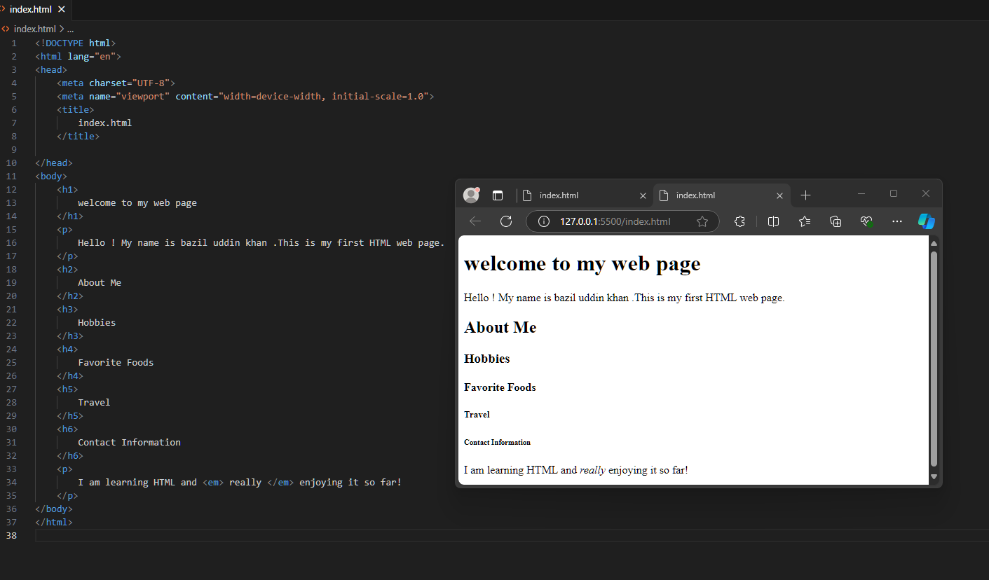
Code:
<!DOCTYPE html>
<html lang="en">
<head>
<meta charset="UTF-8">
<meta name="viewport" content="width=device-width, initial-scale=1.0">
<title>
index.html
</title>

</head>
<body>
<h1>
welcome to my web page
</h1>
<p>
Hello ! My name is bazil uddin khan .This is my first HTML web page.
</p>
<h2>
About Me
</h2>
<h3>
Hobbies
</h3>
<h4>
Favorite Foods
</h4>
<h5>
Travel
</h5>
<h6>
Contact Information
</h6>
<p>
I am learning HTML and <em> really </em> enjoying it so far!
</p>
</body>
</html>

2). 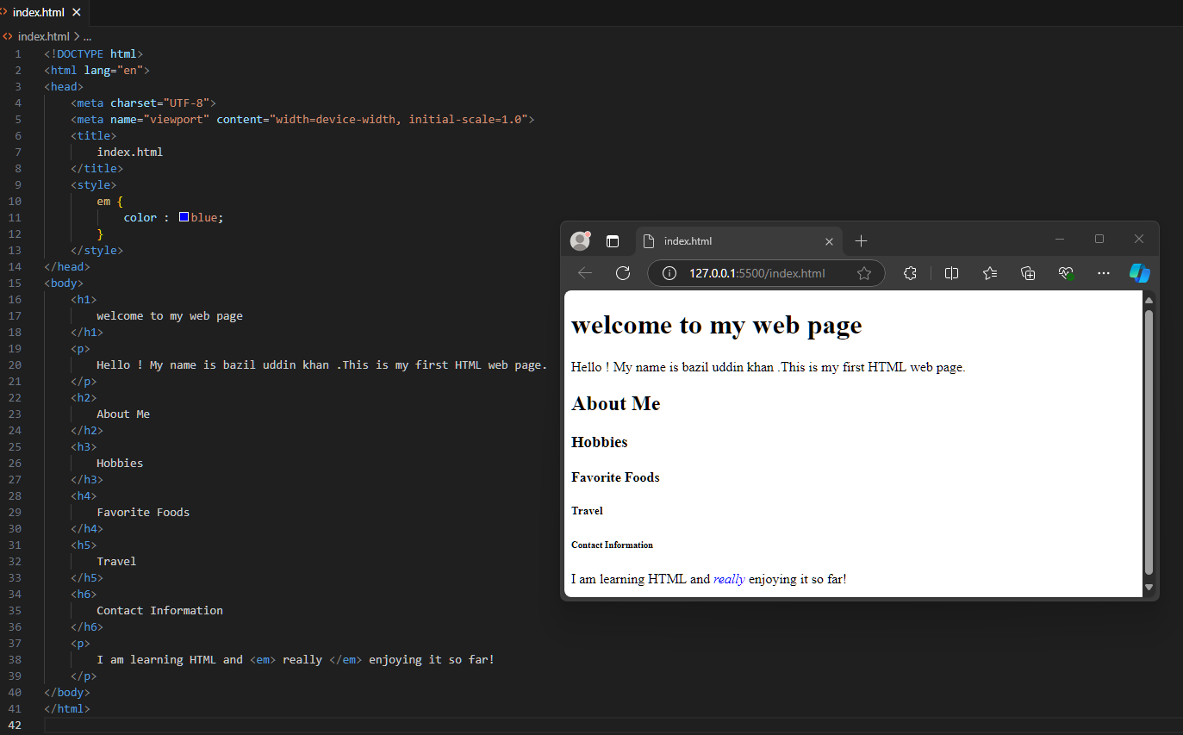
Code:
<!DOCTYPE html>
<html lang="en">
<head>
<meta charset="UTF-8">
<meta name="viewport" content="width=device-width, initial-scale=1.0">
<title>
index.html
</title>
<style>
em{
color : blue;
}
</style>

</head>
<body>
<h1>
welcome to my web page
</h1>
<p>
Hello ! My name is bazil uddin khan .This is my first HTML web page.
</p>
<h2>
About Me
</h2>
<h3>
Hobbies
</h3>
<h4>
Favorite Foods
</h4>
<h5>
Travel
</h5>
<h6>
Contact Information
</h6>
<p>
I am learning HTML and <em> really </em> enjoying it so far!
</p>
</body>
</html>

TASK4).
1). 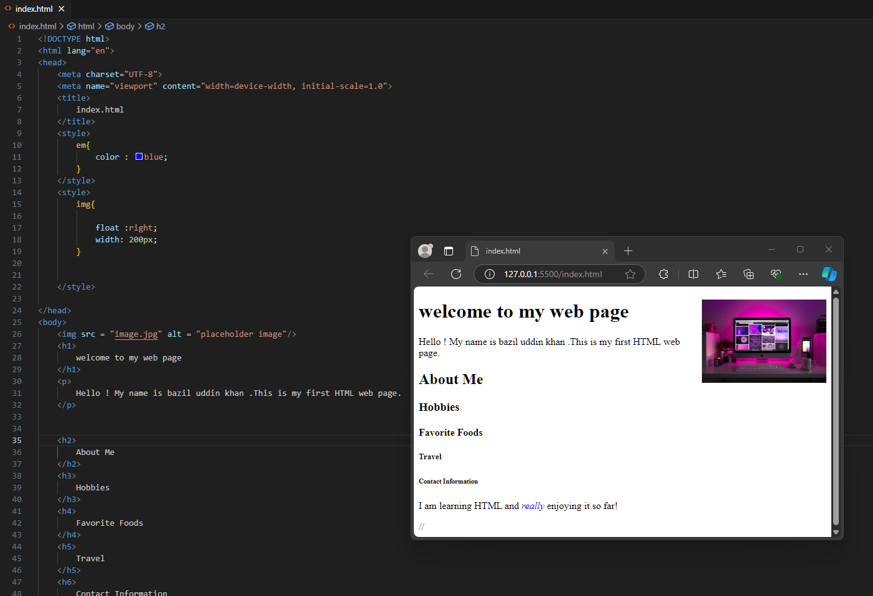
CODE:
<!DOCTYPE html>
<html lang="en">
<head>
<meta charset="UTF-8">
<meta name="viewport" content="width=device-width, initial-scale=1.0">
<title>
index.html
</title>
<style>
em{
color : blue;
}
</style>
<style>
img{

float :right;
width: 200px;
}

</style>

</head>
<body>
<img src = "image.jpg" alt = "placeholder image"/>
<h1>
welcome to my web page
</h1>
<p>
Hello ! My name is bazil uddin khan .This is my first HTML web page.
</p>

<h2>
About Me
</h2>
<h3>
Hobbies
</h3>
<h4>
Favorite Foods
</h4>
<h5>
Travel
</h5>
<h6>
Contact Information
</h6>
<p>
I am learning HTML and <em> really </em> enjoying it so far!
</p>

</body>
</html>

//

TASK5).
1). 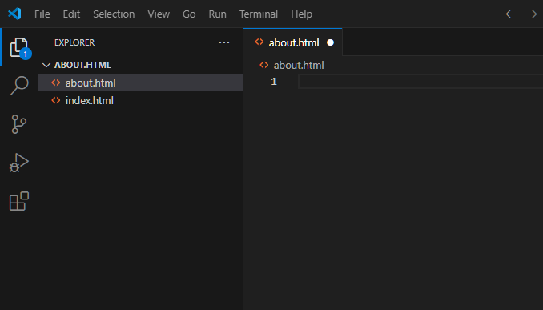
2). 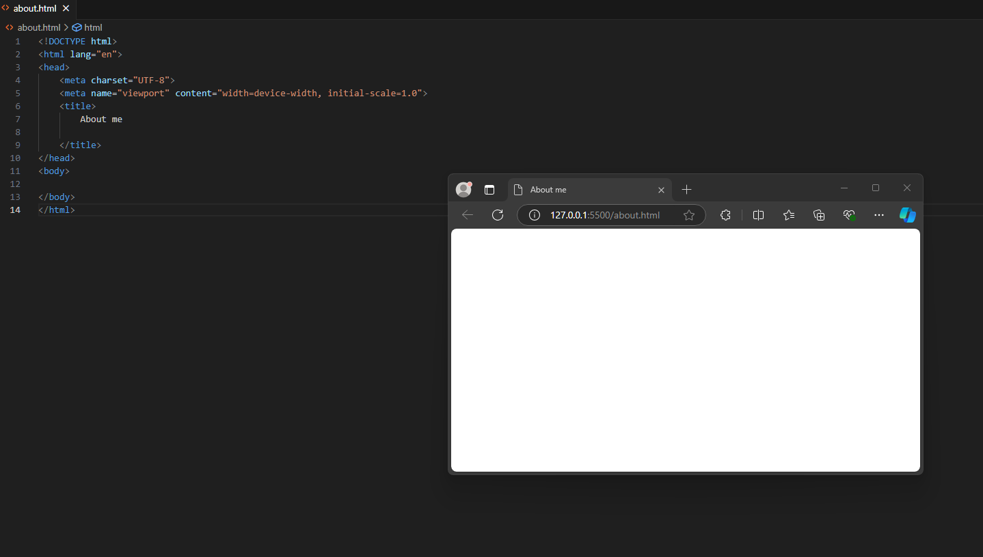

Code:
<!DOCTYPE html>
<html lang="en">
<head>
<meta charset="UTF-8">
<meta name="viewport" content="width=device-width, initial-scale=1.0">
<title>
About me

</title>
</head>
<body>

</body>
</html>

3). 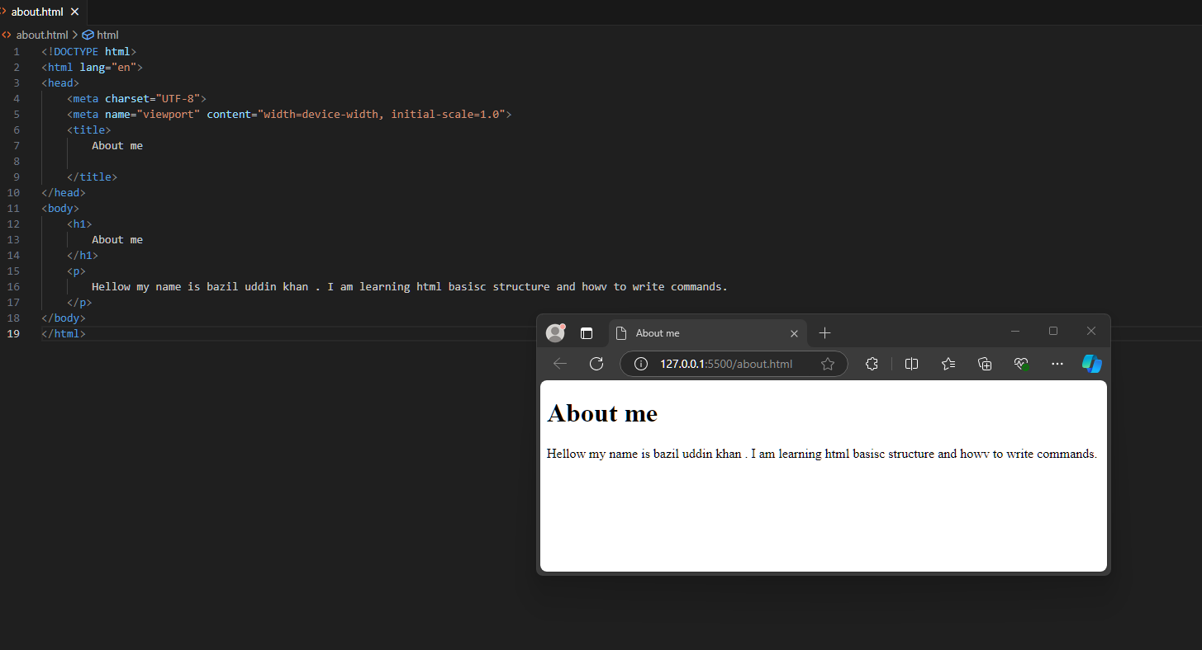

Code:
<!DOCTYPE html>
<html lang="en">
<head>
<meta charset="UTF-8">
<meta name="viewport" content="width=device-width, initial-scale=1.0">
<title>
About me

</title>
</head>
<body>
<h1>
About me
</h1>
<p>
Hellow my name is bazil uddin khan . I am learning html basisc structure and howv to write commands.
</p>
</body>
</html>

4). 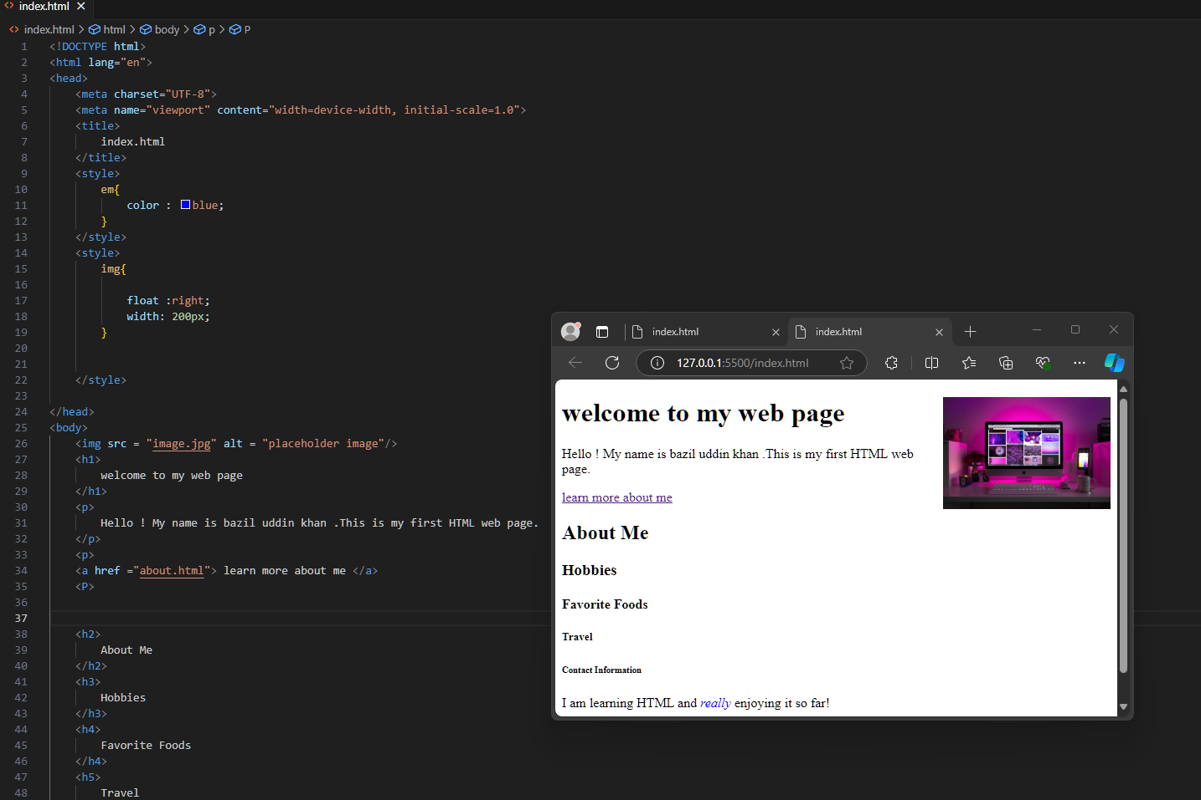
CODE:
<!DOCTYPE html>
<html lang="en">
<head>
<meta charset="UTF-8">
<meta name="viewport" content="width=device-width, initial-scale=1.0">
<title>
index.html
</title>
<style>
em{
color : blue;
}
</style>
<style>
img{

float :right;
width: 200px;
}

</style>

</head>
<body>
<img src = "image.jpg" alt = "placeholder image"/>
<h1>
welcome to my web page
</h1>
<p>
Hello ! My name is bazil uddin khan .This is my first HTML web page.
</p>
<p>
<a href ="about.html"> learn more about me </a>
<P>

<h2>
About Me
</h2>
<h3>
Hobbies
</h3>
<h4>
Favorite Foods
</h4>
<h5>
Travel
</h5>
<h6>
Contact Information
</h6>
<p>
I am learning HTML and <em> really </em> enjoying it so far!
</p>

</body>
</html>

//

